29.44: a) The large circuit is an 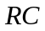 circuit with a time constant of Thus, the current as a function of time is
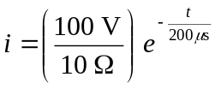
At 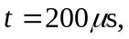 we obtain 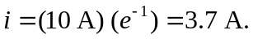
b) Assuming that only the long wire nearest the small loop produces an appreciable magnetic flux through the small loop and referring to the solution of Problem 29.54 we obtain
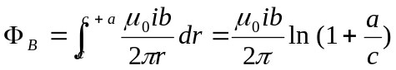

So the emf induced in the small loop at 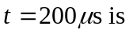

Thus, the induced current in the small loop is 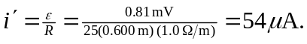
c) The induced current will act to oppose the decrease in flux from the large loop. Thus, the induced current flows counterclockwise.
d) Three of the wires in the large loop are too far away to make a significant contribution to the flux in the small loop–as can be seen by comparing the distance to the dimensions of the large loop.

